August

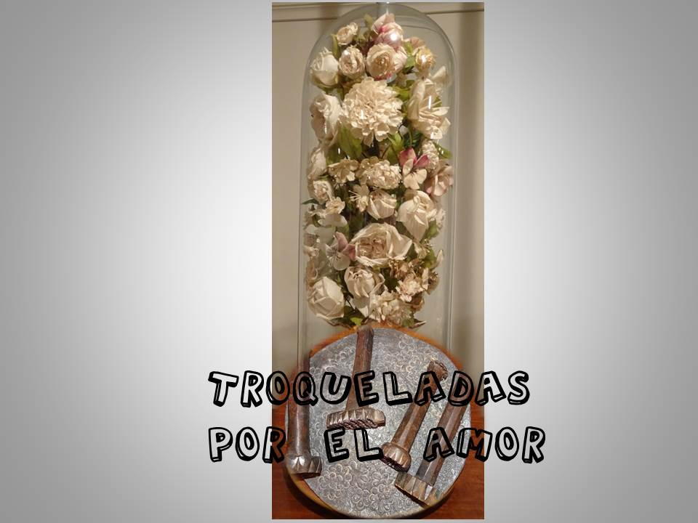

“DIE-CUT BY LOVE”

Symbol: “The die and what is die-cutting”
Moment of Presence of God

Be aware of yourself in this moment and of your Creator; remain in Him, in silence. Allow yourself to be surprised by God’s creativity in everything. Welcome the life given that flows in you; be grateful and celebrate your being in Him: created… loved… chosen… blessed… sent… enjoy the silence. Live yourself die cut by his Love.

Living in the Spirit.

We say that there are “spiritual” persons. In fact, ALL OF US ARE SPIRITUAL PERSONS.

There is within us a presence, a power, a breath that is God Himself beating. And, if we allow Him, then He speaks, but He does not impose Himself.

illusion in bad time,
IS:

strength when we are bent by life,

compassion before misery,

imagination to paint new worlds,

a deep song,

a cry for justice,

the word of love that lifts us when we walk bent,

full body to welcome and love.

We are called to meet God. Up or down. In heaven or in earth. Inside or outside. All the time. Everywhere. They are so many moments!... and in so many ways! “Let us make memory”: In a moment of prayer. In a moment of laughter. In an embrace that comes just when it was needed. In a poem. In silence. In the word. In the concerns that open the door to new solutions. In the people. In calmness. In a celebration. In the one who comes especially wounded, battered… God, in his Spirit, comes to meet me. He keeps on shaping me… Always in the here and now of our inner being.

Song: “Friends of God”

Reflect - Pray - Share
Die cut by God
I have engraved you on the palms of my hands, your ramparts are ever before me. (Is 49:16)
In the book “The true face of Maria Rafols”, written by Jose Luis Martin Descalzo, we find a subtitle that says: “Flowers in the sacristy” and says: (Sister Maria) On her return from Horcajo she has discovered a new -even though in her, it is an already old- vocation: making bouquets of flowers of cloth and making little flowers with a small mould. Even today, in the little museum at the Noviciate in Zaragoza… one can see four bouquets… There us also the small mould and the plate with which she made tiny little flowers. Everything has a fragrance of simplicity and good taste… Under the torment, Sister Maria decided to wait for God to throw light and in few places could she wait for it better than in the apparent uselessness of her work as sacristan… She knows that now they have given her the best part, there, in the luminous darkness of the sacristy.”
Let us enter the sacristy with her; let us contemplate the hours of darkness and silence that Maria Rafols, John Bonal and the First Sisters had to live, and their lives die cut by God’s Love…; let us welcome with love what is “die-cutting” and, above all, let us experience the power and the warmth that still remain “in the die”; let us try to transparent in our lives what is die-cutting. Let us dust off a little the book of Martin Descalzo: “The true face of Maria Rafols”; let us look at its pages with attention and allow ourselves to be surprised, once again, by some few “die-cuttings” among hundreds of them, which we can find in the document. Let us discover again the way how God went on shaping an “origin”, a “mark”, a “hallmark”, which makes us today to be grateful and to live ourselves as “die cut women by God”.
- Together with a giant called John. -AUDACITY-
From the many documents that “the patience and the hard work of Jose Ignacio Tellechea have managed to unearth from here and there… (Fr. John) the figure of a colossus of charity, of one of these personages who would be, on his own, capable of saving a century, arises powerful and enormous.” Together with this giant, Maria will live and we will grow.
John Bonal… was a priest with a complete heart… “Bonal, as Tellechea affirms, was not a priest of mass and stew pot… On the contrary: even before being a priest he lived to the full his vocation of beneficence: in the prisons and in the hospitals is where he had discovered the misery of his time… responded with what he had: with his hands, with his surrender of every day, at the service of the “least” of the Gospel.” In 1804, he was appointed as vicar of the Hospital of the Holy Cross of Barcelona, where, before the request of the Hospital of Zaragoza, he is gained by God, for his Project.
“He was, undoubtedly, the man they required… practical man and he knew very well how complicated the hospital world of his time was, he did not want to launch his daughters and sons on a badly calculated adventure… He stayed at the Hospital for a full month, checking everything. And that tremendous human and economic complex did not frighten him. A man of his enterprising zeal could only be frightened by mediocrity, but neither difficulties nor pain ever detained him. He knew besides, that he could count on human material that the Hospital needed… And it is here when Maria Rafols appears. She is twenty-three years old, but she is a full and courageous woman. She hardly knows any Castilian Spanish, but she is a person capable of adapting herself to all circumstances. Fr. Bonal trusted her. And he was not wrong.”
- In the shadow of The Pillar. -COMMITMENT-
“The enterprise was beginning, as can be seen, with the best omens. But, as “all spiritual adventures are paths of the cross”… After the welcome… “The religious then climbed up to the area where they were installed in their cells. Barcelona was already very far away. The Hospital seemed to exceed the strength of their young arms. But the enterprise seemed so beautiful! Then Maria Rafols was alone, after having consoled and animated the youngest ones. She knew that the true weight would fall on her shoulders, almost as young as those of her companions. At the feet of the Christ whom they had brought with them that young plant of the Congregation that had just found soil in which it would sprout, prayed… Maybe she dreamed. Maybe the tiredness of the trip was stronger than she was and she slept when the Hail Mary to that Virgin whose mantle she had kissed that they for the first time began.”

- A face that transcends, makes itself community. -COMMUNION-
Before the different testimonies about how Mother Maria was physically, Martin Descalzo ends asking: “Will we have to then affirm, once more as for Jesus, that the only manner of knowing Maria Rafols is that evangelical ones of “by their fruits will you know them”?” Yes, the question is quite true; but, it is also true that “here, yes, we are fortunate. Both the gigantic tree of the Congregation planted by her, and the modest little plant that it was while she lived, shout loudly about the sap that flowed through their veins and which had as their direct source Maria Rafols.”
To contemplate the Face of Maria Rafols is to contemplate her own Community. “Because soon, the group of twelve Sisters began to bear fruit in the hospital of Zaragoza. And before long, the spectacular change will be perceived in the organization and in their life…”
“Their life is uphill. Almost inventing their vocation… The day of those twelve women was simply suicidal… A timetable that is at the same time imposing and monotonous… without counting on a little decent space in their work day for personal and free life. With what spirit did they live all this?” No doubt; under the guidelines given by Fr. Bonal, who being a man of very traditional ideology, “in the axes of his spirituality there are some radically modern ideas, we would almost say “postconciliar”, ideas like the realization of the love of God in the love of the neighbour, points like christocentricism, absolute clarity in placing the axis of all virtues in charity… insistence on “love with work” is central for the spirit that Fr. Bonal sowed in the Sisters”, which they lived twenty-four hours a day.
…There isn’t in all the ascetics of the first rules this dichotomy that was so typical of the moment, according to which piety, prayer, spiritual life went on one side and apostolic action or simple social action went along another… There is the complete conviction that the patient is Christ and that attending to him is “another” way of praying. It is from here that in the asceticism of these twelve Sisters the key is in this permanent “presence of Christ”, lived in a permanent way, finding Him in those they served, under an impressive atmosphere with odour of simplicity and poverty…
This cannot be improvised. The group of Sisters counted on a solid support pivot, a strong and dedicate Superior, sweet and energetic, the first in work and in love. And here, as in big buildings: the beam that is least seen is the master beam. But nothing will be sustained without it. We have an infinitely more living portrait in her work, in the high tension that this group that she sustained, captained and inspired, lived. They were souls on fire. And it is known that “for a room to be warm, it is necessary that the fire be burning”. This burning fire was Maria Rafols.
- Heroines of the Sieges. -HEROISM-
All of us know, through the history, the horrors of the two Sieges and the damages provoked by them to the Hospital of Our Lady of Grace.
First Siege: “Together with the fear of the situation, two things stood out in these narrations: the sensation that the transfer was done with order and, within the possible, with serenity; and the interior force as much of the patients as of those who transferred them. What hands, what souls prepared all this? What occult presence of strong souls is there behind this data? Between the barbarism of those who shot and the panic of those who tried to flee, someone has interposed, someone has placed peace and work, someone has made this horrible transfer become possible within a few hours; that each patient was put in his place, and this other miracle, even higher, that the wounded knew to see the hand of God in the midst of their fear. This occult personage -of which the great chroniclers hardly speak- are the Sisters who attend and organize the Hospital. This silent and pacifying personage is called, above all, Maria Rafols.”
Second Siege: “During the sieges of Zaragoza, the essentials were lacking for the sustenance of the patients. And Mother Rafols, with two other religious, one named Tecla Canti and I think the other was called Juliana… managed to arrive in the presence of the French general… They spoke to the French general with so much humility and such persuasive words, that he granted their petitions, giving them provisions and besides a safe-conduct document… so that Mother Rafols and the Sisters could continue collecting the remains and left-overs of bread and meat of the French army. This is how Maria Rafols acquired the right to be considered the angel of the Sieges of Zaragoza… woman who, captaining a group of Sisters, knew to be at the side of the other, much more important canon of love. Where others destroyed, they cured. Where others shot with hatred, they put bandages with love. It was the heroism of those who love in silence, of those who give witness to the fact that God is Life in the midst of death.

- The wind of ingratitude. -HUMILITY-
After ending the war, “sadness dominated the Zaragozans… In these years work multiplied… And now once again the astonishment: in the midst of so much misery, in this climate of absolute hunger…”

The pro-French Board assumes the government of the Hospital. “Ingratitude, this will be the dark shadow that will fill the dream of Mother Maria for several months… The pro-French see in Maria Rafols and Fr. John Bonal two remnants of a world that they want to erase… they are enemies who have to be put out of the game so as to be able to apply their ideas and reforms... Here there will not be war. The pro-French have run into a man and a woman of God, who would fight quietly and clearly, who would let themselves be stepped upon and would accept humiliations in silence. Maybe for them the third great “siege of Zaragoza” would now start.”

“Because the war had begun. And it had three central objectives: the first was to submit the Sisters fully and totally to the desires, style and manner of the new Board. The other two, necessary to achieve the first, were to marginalize Mother Maria and Fr. John, the only ones with prestige to resist this assault. The tactic against Mother Maria was that of the insignificant details”, creating division inside the Sisterhood, till getting the resignation from the Mother, leaving her in the sacristy. There, she, feeling die cut by God, would ruminate one and a thousand times the text of Isaiah while she was making small flowers… I have engraved you on the palms of my hands, your ramparts are ever before me. (Is 49:16)

Fr. John, after absurd battles with the Board, will become the beggar of the Hospital, the ambassador of the poor and will bring the glorious title of “Walker (asking for alms)” of the Hospital.

- A Friendship is born again. -FIDELITY-
“The removal of the pro-French Board brought an armful of blessings for the Sisterhood; the first of them being the reconciliation between Sister Rafols and Mother Canti… Both of them belonged to the first batch of the Sisterhood… as soon as the French domination ceased, Mother Tecla arranged things to entrust Sister Maria with a much more delicate and responsible task… This gesture of friendship must have alleviated Mother Rafols in her solitude and it signified the birth of a new friendship…” The union between them is consolidated and both join their charisms in the solidity of the nascent building… Maria Rafols will find a very hard task along these years… She will live the Gospel, putting and removing diapers, giving bath to small ones who did not even know how to speak most of them. “Losing her life”, as the clever ones of this world would say…

- A hidden light. -HOPE-
The great political nacional problems continue affecting the small group of Sisters. The Sisterhood keeps on crossing the long crisis of survival and growth. Tensions go on with the Board and continues the path of the Sisters towards holiness…

- The deep joy of a shared dream. -JOY-
“The first and highest of all the joys was the canonical approval of the Constitutions (in 1824). This was an old wound: the first rules of the “notebook” were, yes, a treasure of spirituality… We are, evidently, before a crucial happening in the history of the Sisterhood… They are objectively a perfect summary of the “charism” and the spirit that will always characterize the Sisters of Charity of Saint Anne. There are moving pages in them because of the profound christocentric meaning of their norms or for the enormous tenderness with which the topic of charity is treated.” (The two main characters of this adventure were still alive).

- She was counted among the malefactors. -ABANDONMENT-
“Whatever the causes, what is certain is that this harsh 11th of May of 1834 Mother Maria… experienced the shame… Durante dos meses conoció las tristezas de la cárcel… debieron de hacérsele interminables, pues no hay nada más largo que una pena injusta… The Mother will have to spend ten month of anguish waiting for the sentence of her trial… (and) even though no complicity of hers was found, she is exiled… Supporting herself on her shattered health, she would ask to be transferred to Huesca… Now, providentially, this separated pigeon-house will serve as refuge to Mother Maria… This silent Calvary will stretch over six years… If Mother Maria had been capable of irony, how many things she would have said to these generous gentlemen! But she was not capable. She smiled. She bent her head.”

- Write your own experience of woman die cut by God’s Love.
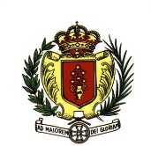
Sisters of Charity of Saint Anne
Zaragoza. General House

JOSE LUIS MARTIN DESCALZO: The true face of Maria Rafols, p. 143.
Ibid.
Cf. p. 55.
Ibid. cf. p. 58 and 70-71.
Ibid. cf. p. 80.
Ibid. cf. pp. 79-91.
Ibíd. cf. pp. 103 and 116-117.
Ibid. cf. pp. 118-120, 123, 125, 127, 138-139.
Ibid. cf. pp. 145-152.
Ibid. cf. pp. 163-164.
Ibid. cf. pp. 180-182, 184-186.

