Gospel 4th April 2021. Easter Sunday Cycle B

LORD OF LIFE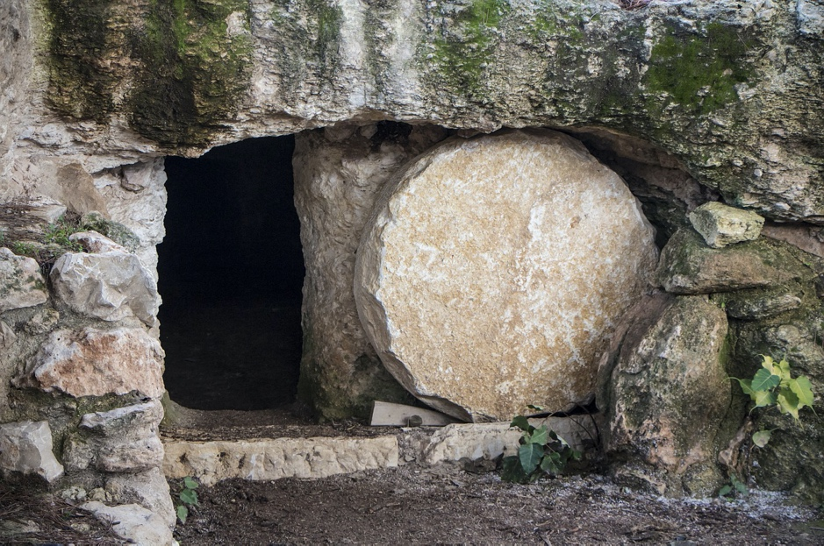
LIFE IS NOT WITHHELD, it is in everything

Setting.

Life flows and floods everything. We go out from the night and we live the dawn for the first time. It is the Lord who walks through life and we find Him in everything.
I place my life in the Life in His hands; may my heart, my hands and my words that come out from deep to the surface, proclaim that love has conquered death and life has meaning, especially when it is lived from gratuitousness to the full donation. You are and I am with you. I contemplate the moved stone.

Song. With the return of the sun. Kentenich Residence School
https://www.youtube.com/watch?v=p0dNkKog1Dw

Gospel according to Saint John: Jn 20:1-9
Early on the first day of the week, while it was still dark, Mary Magdalene went to the tomb and saw that the stone had been removed from the entrance. So, she came running to Simon Peter and the other disciple, the one Jesus loved, and said, “They have taken the Lord out of the tomb, and we don’t know where they have put him!”
So, Peter and the other disciple started for the tomb. Both were running, but the other disciple outran Peter and reached the tomb first. He bent over and looked in at the strips of linen lying there but did not go in. Then Simon Peter came along behind him and went straight into the tomb. He saw the strips of linen lying there, as well as the cloth that had been wrapped around Jesus’ head. The cloth was still lying in its place, separate from the linen. Finally, the other disciple, who had reached the tomb first, also went inside. He saw and believed. They still did not understand from Scripture that Jesus had to rise from the dead.

Deepening the Gospel.
John says that it had not yet dawned: the light of the Resurrection has pierced the darkness; it is thought, evidently: «The light has shone and the darkness has not welcomed it». We also think of the double meaning that the word "to welcome" takes here, which means, at the same time, "to understand" and "to stop"; the darkness has not understood the light, but in spite of everything, the darkness will not be able to stop it in the sense of preventing it from shining. The phrase that says the victory of Jesus Christ is offered to us by Saint John: "Be sure, I have conquered the world!" (Jn 16:33).
And, there it is, "when it had not yet dawned", Mary of Magdala sees that the stone has been removed and runs to find Peter and the "other disciple..." Reaction? John runs, and runs faster, he is younger and comes first, but he lets Peter enter the tomb first. "Then Simon Peter came along behind him and went straight into the tomb. He saw the strips of linen lying there, as well as the cloth that had been wrapped around Jesus’ head. The cloth was still lying in its place, separate from the linen. Finally, the other disciple, who had reached the tomb first, also went inside. He saw and believed." These clothes are the proof that Jesus is already freed from death: the shroud and the cloth that enclosed him symbolized the passivity of death.
The last sentence of our text is somewhat strange: "They still did not understand from Scripture that Jesus had to rise from the dead." What does this mean?
«He saw and believed. They still did not understand from Scripture that Jesus had to rise from the dead...». Because John Believed, he understood the Scripture: until now many passages of Scripture remained obscure. As Saint Anselm said, it is necessary to understand in order to believe, it is necessary to believe in order to understand.
The empty tomb is not a test for us. Our faith will have to be given without more proof than the testimony of the Christian communities that have maintained the faith to our days. Indeed, if we do not have proof, we cannot verify the effects of the Resurrection, which is the profound transformation of people and communities. For our part, let us not wait to understand everything to invite the world to meet the risen Christ!
Clues for the Prayer.
- We look at Mary Magdalene: it was at dawn, when it was dark, what does that mean for me? When I feel like living in the dark, where do I go? what did her heart experience when she saw the slab removed?
- We contemplate Peter, his gestures, his attitudes… what do they tell me?
- We look at John, remember an experience in which you have suddenly seen something clear that you could not perceive, that you did not understand...
- Have you experienced the Resurrection in your life? How do you express this experience on your day to day?

OPEN YOURSELF TO FAITH, may your life flow_________

Ambiental Music. Dreams: New Age Music.
https://www.youtube.com/watch?v=8cJHgS-XXGM

A moved Stone

A radiant morning.
They saw the stone moved.
Surprise, memory, hope.
And my Lord,
where have they place Him?
Life comes,
opening the morning
to the light.
Mary, Peter and John,
communicate, they are witnesses.
It is Easter.
His Light makes us see the light.
Announced presence,
now they understand.
His Easter, our Easter.
The path continues,
from Jerusalem,
they leave and return.
Some crestfallen,
they are still in the dark night.
Accompanied on the way.
Wake up from the dark dream
open your eyes,
to the dream of the light that floods us.
God can move the flagstones,
Life cannot be withheld,
Love conquers all,
understands, believes, celebrates,
loves and shines.
The word overtakes silence,
life overcomes death,
joy conquers sadness,
love transforms everything.
It is Easter,
of light, of the Word, of Life.
We are Easter.

Song. Amaral - Resurection (Official Videoclip)
https://www.youtube.com/watch?v=BuhQcIfJEmA

Sisters of Charity of Saint Anne. Zaragoza

