ADVENT WREATH 2018 - THE WAY OF GOD IS OUR WAY

SECOND ADVENT SUNDAY:

WALK TO THE LAND THAT I WILL SHOW YOU

Song: In the name of the Father, in the name of the Son, in the name of the Holy Spirit. God blessed me. (2)

Guide: About 2,018 years ago Abraham, the father of our faith, obedient to the voice of God, went to an unknown land to give origin to the chosen people.
Some 1,250 years ago, Moses made the sons of Abraham pass through the Red Sea on foot, so that the people, freed from the slavery of Pharaoh, would be the image of the family of the baptized.

Reading: You, Lord, are the God who chose Abraham, took him out of Ur of the Chaldeans and named him Abraham. You saw that his heart was faithful to you and you made a covenant with him to give him the land. And you fulfilled the word because you are loyal. You saw the affliction of our fathers in Egypt, you heard their cries by the Red Sea, and you helped them cross it.

With a pillar of cloud you guided them by day, with pillar of fire, by night, to illuminate the path they had to travel. You gave them righteous standards, valid laws, excellent commands and precepts, through your servant Moses. You sent them bread from heaven when they were hungry, you made water flow from the rock when they were thirsty. And you ordered them to take possession of the land that, with a raised hand, you had sworn to give them. (Cfr. Ne 9:7-15)

Guide: The path has always been an image that evokes change, search, encounter; God in his pedagogy of love proposes it as a promise of salvation and He himself becomes a friend and companion.

"Leave your land", is also the call that resonated 214 years ago in the hearts of John Bonal, Maria Rafols, eleven Sisters and twelve Brothers who, obedient to the voice of God, initiate as a fraternity their way to the land that God was going to show them... When they "leave", they abandon their own security, they place themselves at God's disposal, God’s love and project.
(A minute of silence).

LIGHTING OF THE CANDLE: (A Sister lights the second candle)

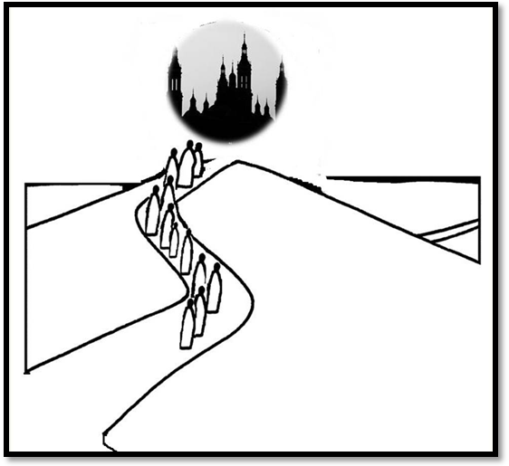Guide 2: With the heart of a mother, God loved his people and agreed with him in fidelity, a new and growing covenant: "I will be your God and you will be my people." When we light this second candle of Advent, let us remember with gratitude the predilection of God for humanity, and let us strengthen the assurance that He keeps watching our tent day and night; with the cloud of his Spirit illuminates our decisions, with the fire of his Presence dispels the shadows of the evil that afflicts us.

All the Sisters: We thank You, oh God, for the invitation that You make us to continue being a community on the way, to break boundaries, to leave ourselves and the security that prevents us from entering the paths that You show us every day. Give us the grace to walk the paths of forgiveness, peace, trust, mutual love and careful service to our brethren.

Advent song.

